**There must be a short and accurate paper describing the architecture/design of the**

**application, the used techniques, the responsibilities, the flow. Start top-level (big**

**picture) and break down. Drawings/Pictures are appreciated! There should be a**

**screenshot of the applications main page and an picture of the group in the**

**documentation.**

**Architecture**

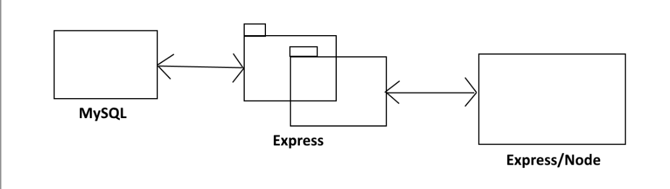

The database structure is as follows:

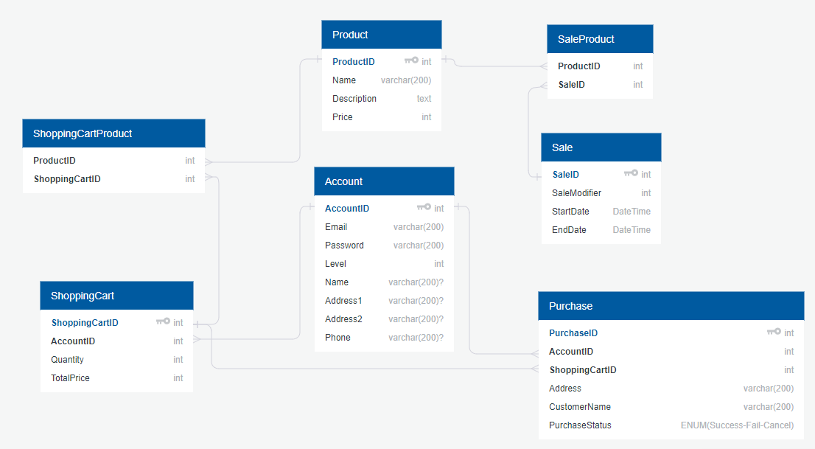

**Techniques**

For our views we used the view engine Mustache, mostly because it was featured in the last workshop we did in the course and we had no experience with any other view engine. Mustache provides a pretty straightforward way to display webpages that feels a lot like writing normal HTML code.

For displaying products on our webshop we used a mySQL database. We gave different attributes to the products so that they had title, price, genre etc. We could later use these attributes to develop the website even more. For example, for the search function we used a query to check the name of the products in the database so that we could search for a certain product. In the shopping cart we used techniques for calculating the price and total quantity for the products.

**Flow**

Our program follows a model-view-controller pattern where the controllers are the routes provided by node express. The user sees the view which has no logic (if statements, loops etc.) in it, and only requests data from the server. Once a request has been sent to the server, the appropriate router answers the call by doing any needed calculations with the help of our model classes and then returns pure html code back to the view, where it is inserted into the page for the user to see.

**Design**

Our application is a webshop and the design of our pages are created with that in mind. We wanted a design that would not be too much style but more simple. The purpose of the application is that you want to buy a product so the design should not make you lose focus. However, the main page has an engaging look to it as well as a slideshow to draw customers in so that they buy a product.

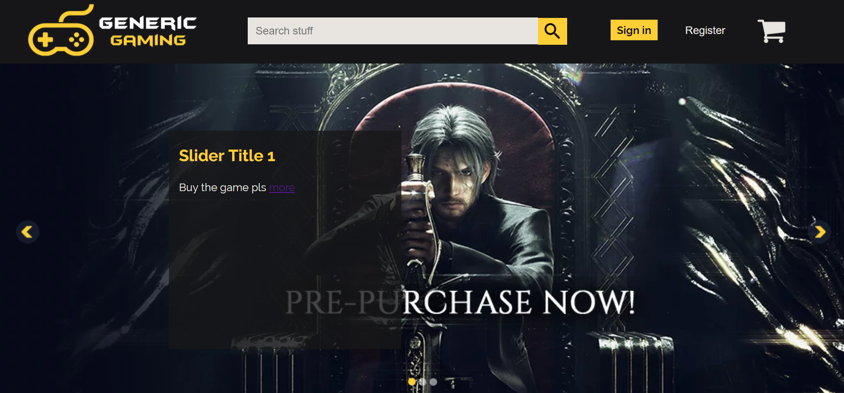

The main page template we have made. This is basically how the end application will look like, however a few changes to the main page can be added. For instance, the shopping cart icon will have a hover function so you can display your cart. We have agreed on the font color as well as the application logo. We also have a slideshow on our main page where we want to promote our products for sale.

Below is the first template for how the products will be displayed. Pictures will later be added to the products so that the buyer knows what product it is.

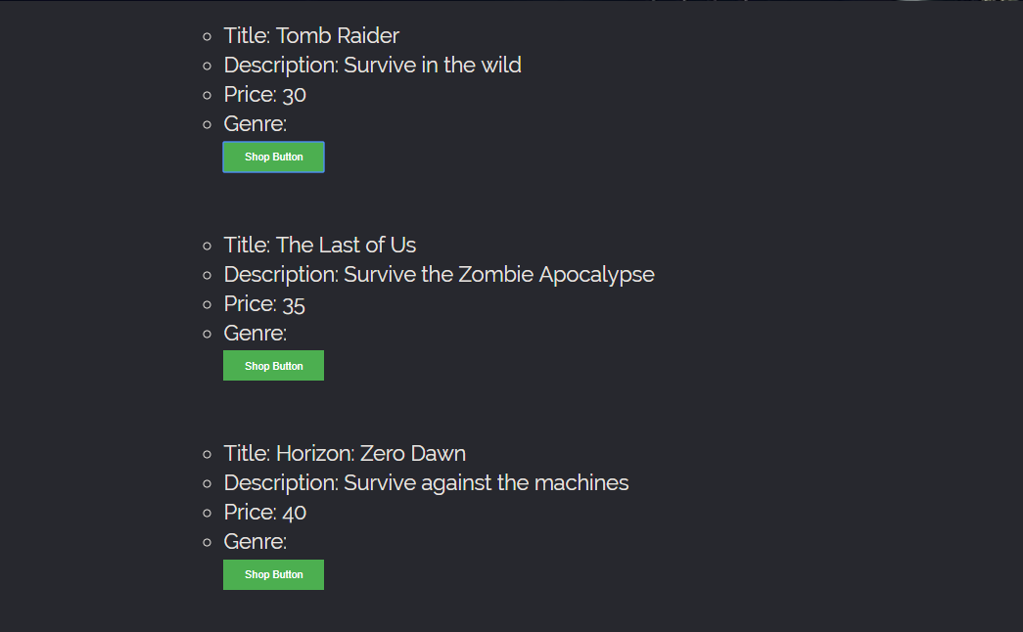

Login to your account when clicking on the button on the home page. The admin will have a special role and can do other things on the page that normal users can not.

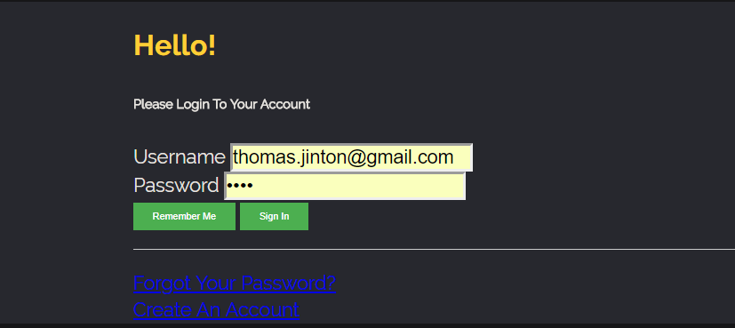

Below is the first template for the admin page. This is where you can add a product, delete a product and also add a sale price.

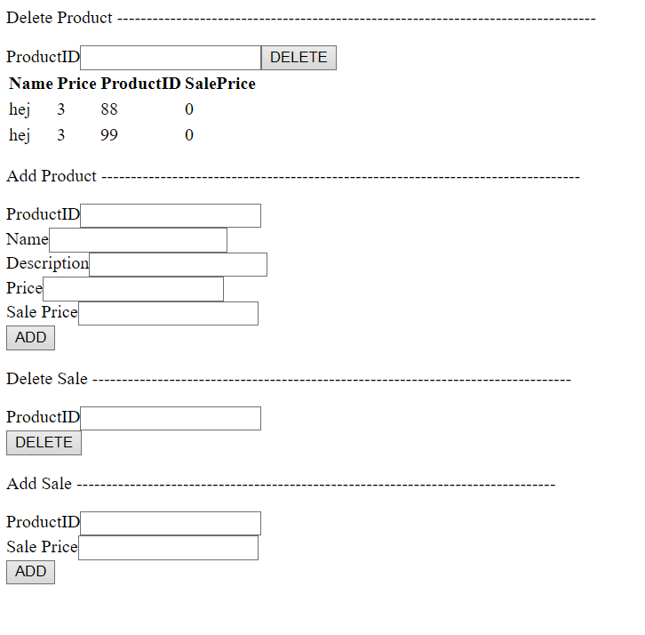

When you press the “add to cart” button you can find your products in the shopping cart menu. Here you can add more products on the one you picked or delete them etc.

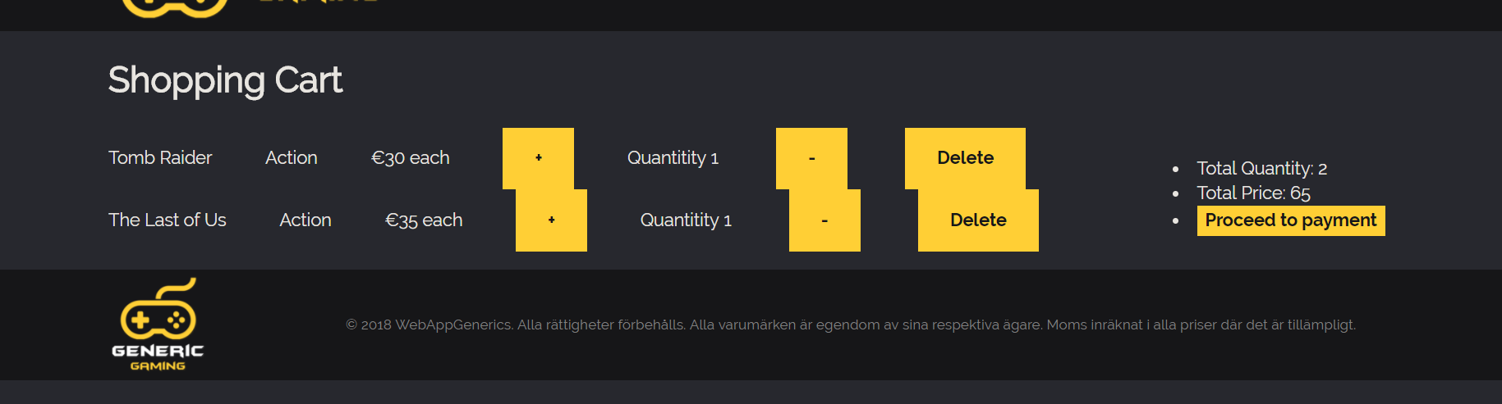

**Group Members**

**Emir Zivcic**



**Janne Rasmussen**



**Kevin Solovjov**



**Thomas Jinton**

